MONTH of JUNE
Sunday | Monday | Tuesday | Wednesday | Thursday | Friday | Saturday
 | 27 1st Day of POOL  Lap Swim 12-1pm | 28  Lap Swim 12-1pm | 29  Lap Swim 12-1pm | 30  Lap Swim 12-1pm | 31  Lap Swim 12-1pm | 1  Pool Party  10:30-12:30:  6:30-8:30: Melissa Schwartman 297-8323
2  Pool Party  10:30-12:30: | 3 Swim Lessons 10:15-11am; 11:10-11:55am;  5-5:45pm  Lap Swim 12-1pm | 4 Swim Lessons 10:15-11am; 11:10-11:55am;  5-5:45pm  Lap Swim 12-1pm | 5 Swim Lessons 10:15-11am; 11:10-11:55am;  5-5:45pm  Lap Swim 12-1pm | 6 Swim Lessons 10:15-11am; 11:10-11:55am;  5-5:45pm  Lap Swim 12-1pm | 7  Lap Swim 12-1pm | 8  Pool Party  10:30-12:30: Kara Teten  6:30-8:30: Matt Pollard 689-1426
9  Pool Party  10:30-12:30: | 10 Swim Lessons 10:15-11am; 11:10-11:55am;  5-5:45pm  Lap Swim 12-1pm | 11 Swim Lessons 10:15-11am; 11:10-11:55am;  5-5:45pm  Lap Swim 12-1pm | 12 Swim Lessons 10:15-11am; 11:10-11:55am;  5-5:45pm  Lap Swim 12-1pm | 13 Swim Lessons 10:15-11am; 11:10-11:55am;  5-5:45pm  Lap Swim 12-1pm | 14  Lap Swim 12-1pm | 15  Pool Party  10:30-12:30:  6:30-8:30: 4H Jacki Stubbendick  525-4879
16  Pool Party  10:30-12:30: | 17 Swim Lessons 10:15-11am; 11:10-11:55am;  5-5:45pm  Lap Swim 12-1pm | 18 Swim Lessons 10:15-11am; 11:10-11:55am;  5-5:45pm  Lap Swim 12-1pm | 19 Swim Lessons 10:15-11am; 11:10-11:55am;  5-5:45pm  Lap Swim 12-1pm | 20 Swim Lessons 10:15-11am; 11:10-11:55am;  5-5:45pm  Lap Swim 12-1pm | 21  Lap Swim 12-1pm | 22  Pool Party  10:30-12:30: Maddie Hughes 570-7795  6:30-8:30:
23 Pool Party  10:30-12:30:  30 Pool Party  10:30-12:30:  ?Shelby Patton? | 24 Swim Lessons 11:10-11:55am;  5-5:45pm  Lap Swim 12-1pm | 25 Swim Lessons 11:10-11:55am;  5-5:45pm  Lap Swim 12-1pm | 26 Swim Lessons 11:10-11:55am;  5-5:45pm  Lap Swim 12-1pm | 27 Swim Lessons 11:10-11:55am;  5-5:45pm  Lap Swim 12-1pm | 28  Lap Swim 12-1pm | 29  Pool Party  10:30-12:30:  6:30-8:30: Megan Bradburry 269-4019

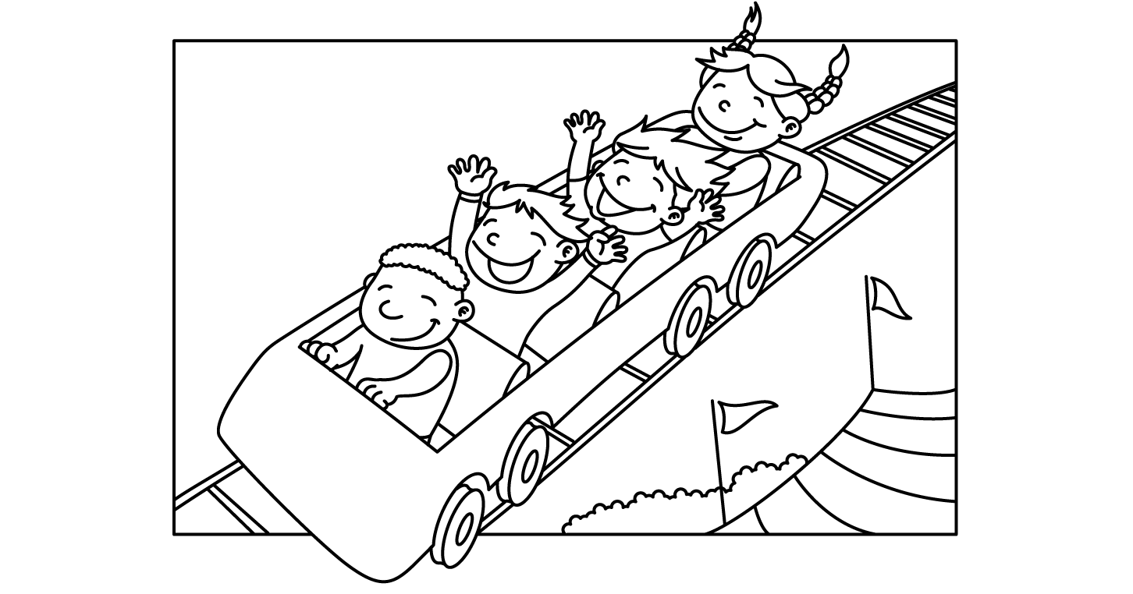

MONTH of JULY
Sunday | Monday | Tuesday | Wednesday | Thursday | Friday | Saturday
 | 1  Lap Swim 12-1pm | 2  Lap Swim 12-1pm | 3  Lap Swim 12-1pm | 4  Lap Swim 12-1pm | 5  Lap Swim 12-1pm | 6  Pool Party  10:30-12:30:  6:30-8:30:
7  Pool Party  10:30-12:30: | 8  Lap Swim 12-1pm | 9  Lap Swim 12-1pm | 10  Lap Swim 12-1pm | 11  Lap Swim 12-1pm | 12  Lap Swim 12-1pm | 13  Pool Party  10:30-12:30:  6:30-8:30: Extension Office Erin Steinhoff 297-1210
14  Pool Party  10:30-12:30: | 15  Lap Swim 12-1pm | 16  Lap Swim 12-1pm | 17  Lap Swim 12-1pm | 18  Lap Swim 12-1pm | 19  Lap Swim 12-1pm | 20  Pool Party  10:30-12:30:  6:30-8:30:
21  Pool Party  10:30-12:30: | 22  Lap Swim 12-1pm | 23  Lap Swim 12-1pm | 24  Lap Swim 12-1pm | 25  Lap Swim 12-1pm | 26  Lap Swim 12-1pm | 27  Pool Party  10:30-12:30:  6:30-8:30:
28  Pool Party  10:30-12:30: | 29  Lap Swim 12-1pm | 30  Lap Swim 12-1pm | 31  Lap Swim 12-1pm

MONTH of AUGUST
Sunday | Monday | Tuesday | Wednesday | Thursday | Friday | Saturday
 |  |  |  | 1  Lap Swim 12-1pm | 2  Lap Swim 12-1pm | 3  Pool Party  10:30-12:30:  6:30-8:30:
4  Pool Party  10:30-12:30: | 5  Lap Swim 12-1pm | 6  Lap Swim 12-1pm | 7  Lap Swim 12-1pm | 8  Lap Swim 12-1pm | 9  Lap Swim 12-1pm | 10  Pool Party  10:30-12:30:  6:30-8:30:
11  Pool Party  10:30-12:30: | 12  Lap Swim 12-1pm | 13  Lap Swim 12-1pm | 14  1st Day of School  Pool open 4-7pm ONLY | 15  Pool open 4-7pm ONLY | 16  Pool open 4-7pm ONLY | 17  Pool Party  10:30-12:30:  6:30-8:30:
18  Pool Party  10:30-12:30 | 19  Pool open 4-7pm ONLY | 20  Pool open 4-7pm ONLY | 21  Pool open 4-7pm ONLY | 22  Pool open 4-7pm ONLY | 23  Pool open 4-7pm ONLY | 24  End of Season Bash
25 | 26 | 27 | 28 | 29 | 30 | 31

