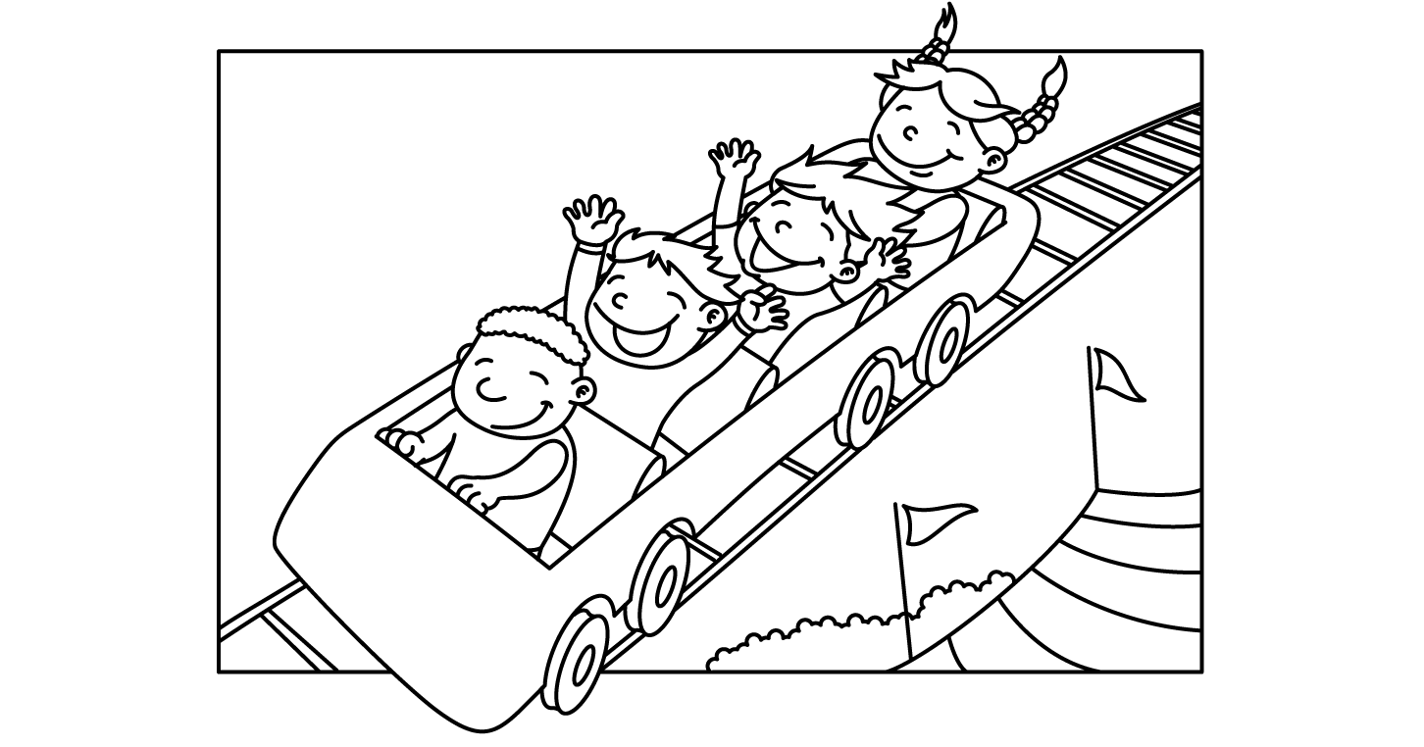

MONTH of JULY
Sunday | Monday | Tuesday | Wednesday | Thursday | Friday | Saturday
 | 1  Lap Swim 12-1pm  Lap Swim 5-6pm  Private: 10am  10:30, 11, 11:30, 12; 12:30; 5, 5:30 | 2  Lap Swim 12-1pm  Lap Swim 5-6pm  Private: 10am  10:30, 11, 11:30, 12; 12:30; 5, 5:30 | 3  Lap Swim 12-1pm  Lap Swim 5-6pm  Private: 10am  10:30, 11, 11:30, 12; 12:30; 5, 5:30 | 4  Lap Swim 12-1pm  Private: 10am  10:30, 11, 11:30, 12; 12:30  Closed at 5pm | 5  Lap Swim 12-1pm  Lap Swim 5-6pm  Private: 10am  10:30, 11, 11:30, 12; 12:30; 5, 5:30 | 6  Pool Party  10:30-12:30:  6:30-8:30: JoDee Paulsen 269-5167
7  Pool Party  10:30-12:30: | 8  Lap Swim 12-1pm  Lap Swim 5-6pm  Private: 10am  10:30, 11, 11:30, 12; 12:30; 5, 5:30 | 9  Lap Swim 12-1pm  Lap Swim 5-6pm  Private: 10am  10:30, 11, 11:30, 12; 12:30; 5, 5:30 | 10  Lap Swim 12-1pm  Lap Swim 5-6pm  Private: 10am  10:30, 11, 11:30, 12; 12:30; 5, 5:30 | 11  Lap Swim 12-1pm  Lap Swim 5-6pm  Private: 10am  10:30, 11, 11:30, 12; 12:30; 5, 5:30 | 12  Lap Swim 12-1pm  Lap Swim 5-6pm  Private: 10am  10:30, 11, 11:30, 12; 12:30; 5, 5:30 | 13  Pool Party  10:30-12:30: Jessica Lindsmidth 402-730-6838  6:30-8:30: Extension Office Erin Steinhoff 297-1210
14  Pool Party  10:30-12:30:  E/M Softball team 6-8pm $2/ea. | 15  Lap Swim 12-1pm  Lap Swim 5-6pm  Private: 10am  10:30, 11, 11:30, 12; 12:30; 5, 5:30 | 16  Lap Swim 12-1pm  Lap Swim 5-6pm  Private: 10am  10:30, 11, 11:30, 12; 12:30; 5, 5:30 | 17  Lap Swim 12-1pm  Lap Swim 5-6pm  Private: 10am  10:30, 11, 11:30, 12; 12:30; 5, 5:30 | 18  Lap Swim 12-1pm  Lap Swim 5-6pm  Private: 10am  10:30, 11, 11:30, 12; 12:30; 5, 5:30 | 19  Lap Swim 12-1pm  Lap Swim 5-6pm  Private: 10am  10:30, 11, 11:30, 12; 12:30; 5, 5:30 | 20  Pool Party  10:30-12:30: Brianne 1999 Reunion 297-6616  6:30-8:30: Swim Team 402-269-4220 Karla
21  Pool Party  10:30-12:30: Katie Kosch 610-0194 | 22  Lap Swim 12-1pm  Lap Swim 5-6pm  Private: 10am  10:30, 11, 11:30, 12; 12:30; 5, 5:30 | 23  Lap Swim 12-1pm  Lap Swim 5-6pm  Private: 10am  10:30, 11, 11:30, 12; 12:30; 5, 5:30 | 24  Lap Swim 12-1pm  Lap Swim 5-6pm  Private: 10am  10:30, 11, 11:30, 12; 12:30; 5, 5:30 | 25  Lap Swim 12-1pm  Lap Swim 5-6pm  Private: 10am  10:30, 11, 11:30, 12; 12:30; 5, 5:30 | 26  Lap Swim 12-1pm  Lap Swim 5-6pm  Private: 10am  10:30, 11, 11:30, 12; 12:30; 5, 5:30 | 27  Pool Party  6:30-8:30: Elle Foley 619-770-9478  6:30-8:30: Lilly Chambers 440-2871
28 | 29  Lap Swim 12-1pm  Lap Swim 5-6pm  Private: 10am  10:30, 11, 11:30, 12; 12:30; 5, 5:30 | 30  Lap Swim 12-1pm  Lap Swim 5-6pm  Private: 10am  10:30, 11, 11:30, 12; 12:30; 5, 5:30 | 31  Lap Swim 12-1pm  Lap Swim 5-6pm  Private: 10am  10:30, 11, 11:30, 12; 12:30; 5, 5:30

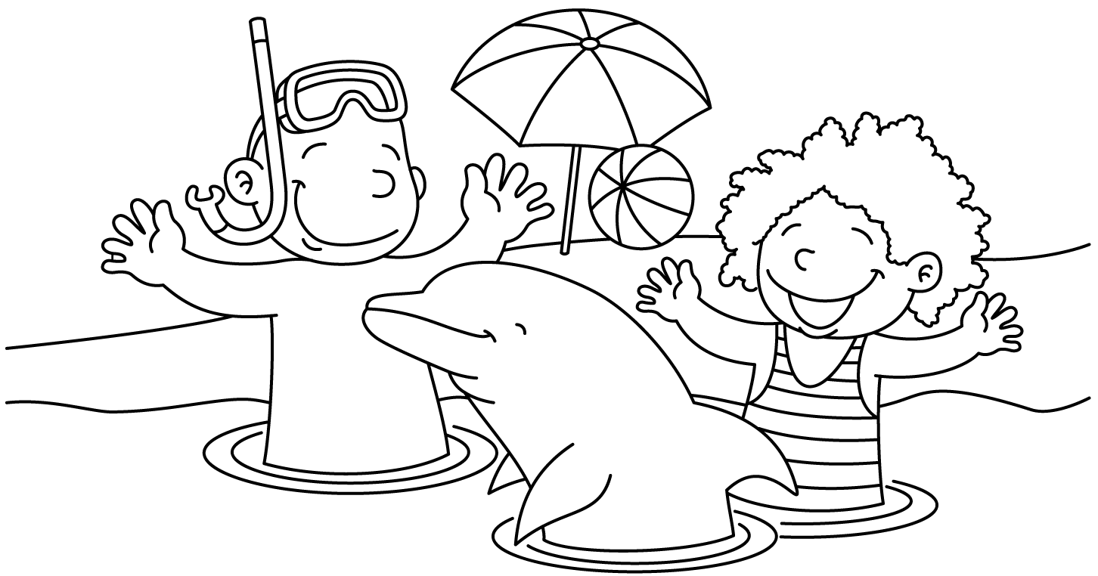

MONTH of AUGUST
Sunday | Monday | Tuesday | Wednesday | Thursday | Friday | Saturday
 |  |  |  | 1  Lap Swim 12-1pm  Lap Swim 5-6pm  Private: 10am  10:30, 11, 11:30, 12; 12:30; 5, 5:30: | 2  Lap Swim 12-1pm  Lap Swim 5-6pm  Private: 10am  10:30, 11, 11:30, 12; 12:30; 5, 5:30: | 3  Pool Party  10:30-12:30: Natalie Schmidt 540-3324  6:30-8:30: Nicole Keslar770-5965
4  Pool Party  10:30-12:30: Katie Nash 867-4286 | 5  Lap Swim 12-1pm  Lap Swim 5-6pm  Private: 10am  10:30, 11, 11:30, 12; 12:30; 5, 5:30: | 6  Lap Swim 12-1pm  Lap Swim 5-6pm  Private: 10am  10:30, 11, 11:30, 12; 12:30; 5, 5:30: | 7  Lap Swim 12-1pm  Lap Swim 5-6pm  Private: 10am  10:30, 11, 11:30, 12; 12:30; 5, 5:30: | 8  Lap Swim 12-1pm  Lap Swim 5-6pm  Private: 10am  10:30, 11, 11:30, 12; 12:30; 5, 5:30: | 9  Lap Swim 12-1pm  Lap Swim 5-6pm  Private: 10am  10:30, 11, 11:30, 12; 12:30; 5, 5:30: | 10  Pool Summer Bash!! FREE SWIM!!
11  Pool Party  10:30-12:30:  Stephanie Cavelier 792-413-1433 | 12  Lap Swim 12-1pm  Lap Swim 5-6pm  Private: 10am  10:30, 11, 11:30, 12; 12:30; 5, 5:30: | 13  Lap Swim 12-1pm  Lap Swim 5-6pm  Private: 10am  10:30, 11, 11:30, 12; 12:30; 5, 5:30: | 14  1st Day of School  Pool open 4-7pm ONLY  NO LAP SWIM | 15  Pool open 4-7pm ONLY  NO LAP SWIM | 16  Pool open 4-7pm ONLY  NO LAP SWIM | 17  10:30-12:30  Girl Scouts 432-9759  6:30-8:30: Holly Armagost 440-9834
18  Pool Party  10:30-12:30 Pastor Andy St. Johns UCC 873-2125 | 19  Pool open 4-7pm ONLY  NO LAP SWIM | 20  Pool open 4-7pm ONLY  NO LAP SWIM | 21  Pool open 4-7pm ONLY  NO LAP SWIM | 22  Pool open 4-7pm ONLY  NO LAP SWIM | 23  Pool open 4-7pm ONLY  NO LAP SWIM | 24  End of Season Bash
25 | 26 | 27 | 28 | 29 | 30 | 31

