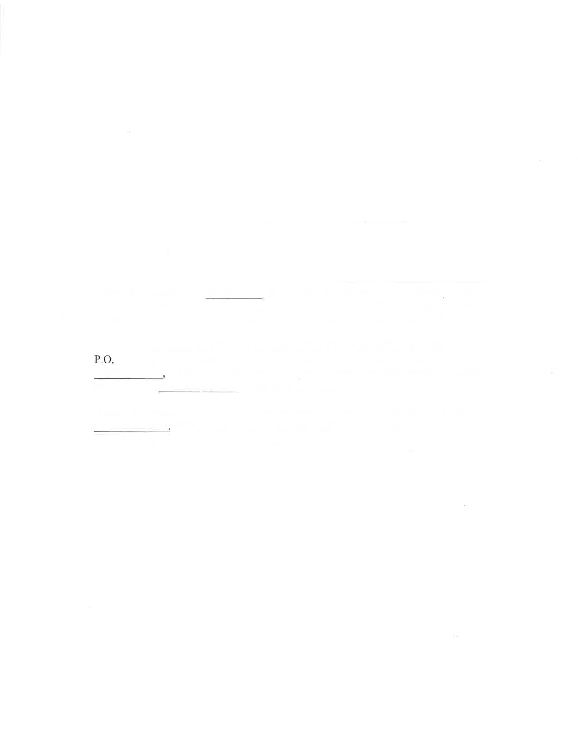

NOTICE OF SALE OF PERSONAL PROPERTY

CITY OF SYRACUSE, NEBRASKA

Pursuant to Resolution 19-31

of the City of Syracuse, Otoe County. Nebraska, the

following notice is given offering an ambulance, a 2003 Ford E450 Cutaway Van Super, VIN 1FDXE45F63H837286. for sale by sealed bid upon the following terms and conditions:

All sealed bids must be received at the office of the City Clerk of the City of Syracuse,

Box F, 495 Midland Street, Syracuse, Nebraska 68446, at or before 4:00 p.m. on

Feb

ruary 11

2020.

The bids shall be opened during the city council meeting

scheduled for February

IzEh ,202Oat

6:00 p.m,

Terms of payment shall be cash or guaranteed funds paid within 10 days of

February 12th

2020 al which time possession will be given to the purchaser. The

City of Syracuse reserves the right to reject all bids.