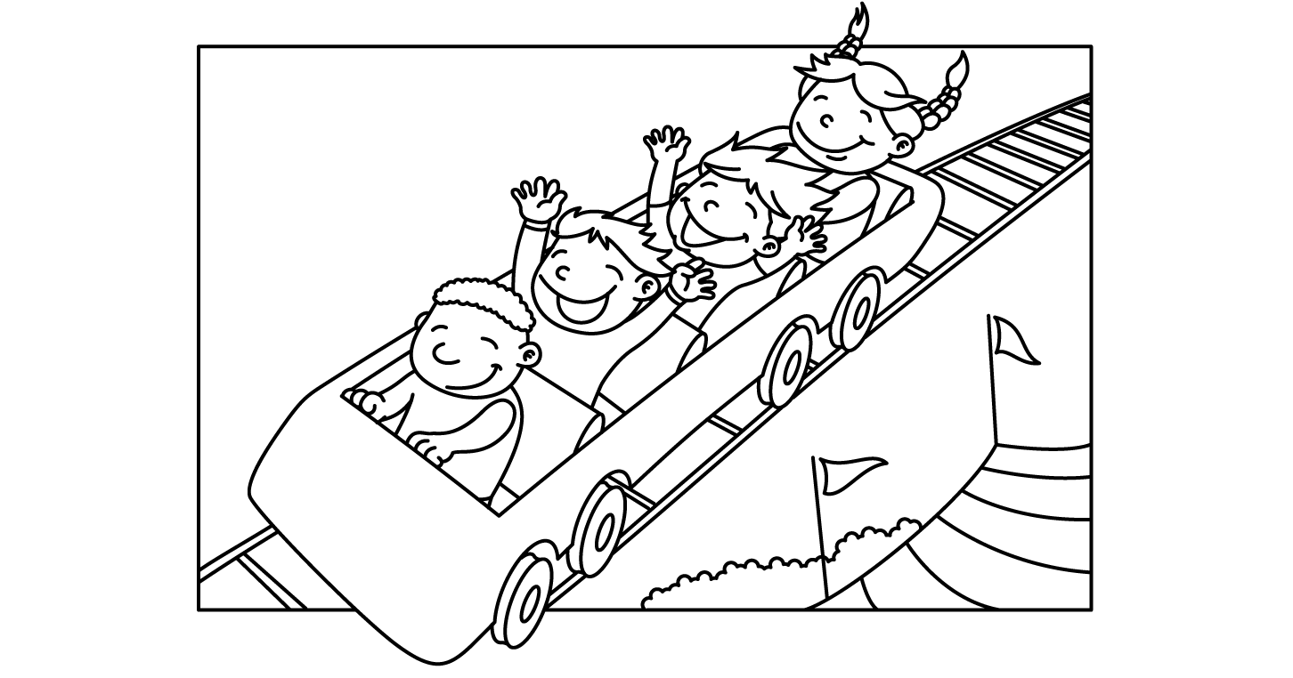

MONTH of JULY 2020
Sunday | Monday | Tuesday | Wednesday | Thursday | Friday | Saturday
 |  |  | 1  Lap Swim 12-1pm  Lap Swim 5-6pm  Private: 11, 11:30, 12; 12:30; 5, 5:30 | 2  Lap Swim 12-1pm  Private: 10am  10:30, 11, 11:30, 12; 12:30  Closed at 5pm | 3  Lap Swim 12-1pm  Lap Swim 5-6pm  Private: 11, 11:30, 12; 12:30; 5, 5:30 | 4  Pool Party  10:30-12:30  Pool Closed @5pm!!
5  Pool Party  10:30-12:30 | 6  Lap Swim 12-1pm  Lap Swim 5-6pm  Private: 11, 11:30, 12; 12:30; 5, 5:30 | 7  Lap Swim 12-1pm  Lap Swim 5-6pm  Private: 11, 11:30, 12; 12:30; 5, 5:30 | 8  Lap Swim 12-1pm  Lap Swim 5-6pm  Private: 11, 11:30, 12; 12:30; 5, 5:30 | 9  Lap Swim 12-1pm  Lap Swim 5-6pm  Private: 11, 11:30, 12; 12:30; 5, 5:30 | 10  Lap Swim 12-1pm  Lap Swim 5-6pm  Private: 11, 11:30, 12; 12:30; 5, 5:30 | 11  Pool Party  10:30-12:30  6:30-8:30:
12  Pool Party  10:30-12:30 | 13  Lap Swim 12-1pm  Lap Swim 5-6pm  Private: 11, 11:30, 12; 12:30; 5, 5:30 | 14  Lap Swim 12-1pm  Lap Swim 5-6pm  Private: 11, 11:30, 12; 12:30; 5, 5:30 | 15  Lap Swim 12-1pm  Lap Swim 5-6pm  Private: 11, 11:30, 12; 12:30; 5, 5:30 | 16  Lap Swim 12-1pm  Lap Swim 5-6pm  Private: 11, 11:30, 12; 12:30; 5, 5:30 | 17  Lap Swim 12-1pm  Lap Swim 5-6pm  Private: 11, 11:30, 12; 12:30; 5, 5:30 | 18  Pool Party  10:30-12:30  6:30-8:30:
19  Pool Party  10:30-12:30 | 20  Lap Swim 12-1pm  Lap Swim 5-6pm  Private: 11, 11:30, 12; 12:30; 5, 5:30 | 21  Lap Swim 12-1pm  Lap Swim 5-6pm  Private: 11, 11:30, 12; 12:30; 5, 5:30 | 22  Lap Swim 12-1pm  Lap Swim 5-6pm  Private: 11, 11:30, 12; 12:30; 5, 5:30 | 23  Lap Swim 12-1pm  Lap Swim 5-6pm  Private: 11, 11:30, 12; 12:30; 5, 5:30 | 24  Lap Swim 12-1pm  Lap Swim 5-6pm  Private: 11, 11:30, 12; 12:30; 5, 5:30 | 25  Pool Party  10:30-12:30  6:30-8:30:
26  Pool Party  10:30-12:30 | 27  Lap Swim 12-1pm  Lap Swim 5-6pm  Private: 11, 11:30, 12; 12:30; 5, 5:30 | 28  Lap Swim 12-1pm  Lap Swim 5-6pm  Private: 11, 11:30, 12; 12:30; 5, 5:30 | 29  Lap Swim 12-1pm  Lap Swim 5-6pm  Private: 11, 11:30, 12; 12:30; 5, 5:30 | 30  Lap Swim 12-1pm  Lap Swim 5-6pm  Private: 11, 11:30, 12; 12:30; 5, 5:30 | 31  Lap Swim 12-1pm  Lap Swim 5-6pm  Private: 11, 11:30, 12; 12:30; 5, 5:30

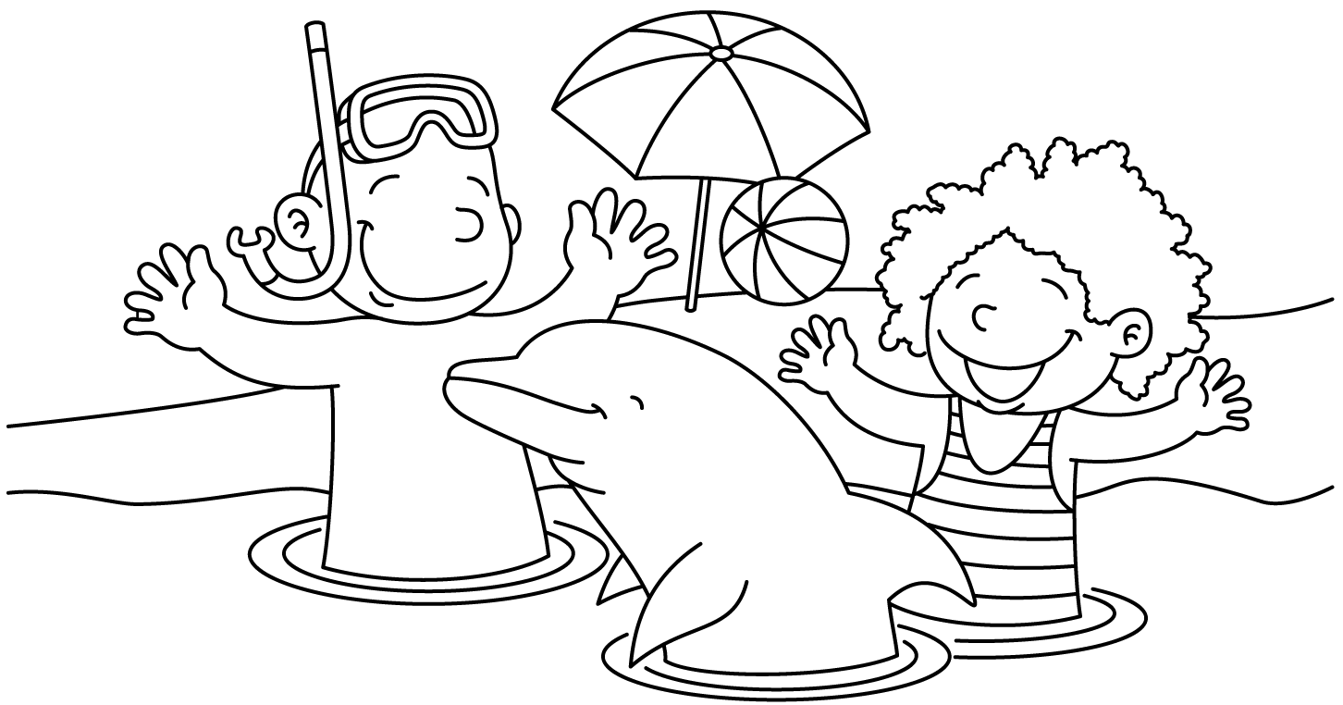

MONTH of AUGUST 2020
Sunday | Monday | Tuesday | Wednesday | Thursday | Friday | Saturday
1
Pool Party
10:30-12:30

6:30-8:30:
2  Pool Party  10:30-12:30 | 3  Lap Swim 12-1pm  Lap Swim 5-6pm  Private: 10am  10:30, 11, 11:30, 12; 12:30; 5, 5:30: | 4  Lap Swim 12-1pm  Lap Swim 5-6pm  Private: 10am  10:30, 11, 11:30, 12; 12:30; 5, 5:30: | 5  Lap Swim 12-1pm  Lap Swim 5-6pm  Private: 10am  10:30, 11, 11:30, 12; 12:30; 5, 5:30: | 6  Lap Swim 12-1pm  Lap Swim 5-6pm  Private: 10am  10:30, 11, 11:30, 12; 12:30; 5, 5:30: | 7  Lap Swim 12-1pm  Lap Swim 5-6pm  Private: 10am  10:30, 11, 11:30, 12; 12:30; 5, 5:30: | 8  Pool Party  10:30-12:30  6:30-8:30:
9  NO pool Party | 10  Lap Swim 12-1pm  Lap Swim 5-6pm  Private: 10am  10:30, 11, 11:30, 12; 12:30; 5, 5:30: | 11  Lap Swim 12-1pm  Lap Swim 5-6pm  Private: 10am  10:30, 11, 11:30, 12; 12:30; 5, 5:30  LAST DAY LAP SWIM | 12  1st Day of School  Pool open 4-7pm ONLY  NO LAP SWIM | 13  Pool open 4-7pm ONLY  **SCHOOL SWIM**  NO LAP SWIM | 14  Pool CLOSED  Employees to help empty bathhouse after school | 15  Start Construction of NEW BATHHOUSE!!
16 | 17 | 18 | 19 | 20 | 21 | 22
23 | 24 | 25 | 26 | 27 | 28 | 29

MONTH of June 2020
Sunday | Monday | Tuesday | Wednesday | Thursday | Friday | Saturday
 | 1  Lap Swim 12-1pm  Lap Swim 5-6pm  Public Lessons: 10:15-11am; 11:15-noon;  5-5:45pm | 2  Lap Swim 12-1pm  Lap Swim 5-6pm  Public Lessons: 10:15-11am; 11:15-noon;  5-5:45pm | 3  Lap Swim 12-1pm  Lap Swim 5-6pm  Public Lessons: 10:15-11am; 11:15-noon;  5-5:45pm | 4  Lap Swim 12-1pm  Lap Swim 5-6pm  Public Lessons: 10:15-11am; 11:15-noon;  5-5:45pm | 5  Lap Swim 12-1pm  Lap Swim 5-6pm | 6  Pool Party  10:30-12:30  6:30-8:30:
7  Pool Party  10:30-12:30 | 8  Lap Swim 12-1pm  Lap Swim 5-6pm  Public Lessons: 10:15-11am; 11:15-noon;  5-5:45pm | 9  Lap Swim 12-1pm  Lap Swim 5-6pm  Public Lessons: 10:15-11am; 11:15-noon;  5-5:45pm | 10  Lap Swim 12-1pm  Lap Swim 5-6pm  Public Lessons: 10:15-11am; 11:15-noon;  5-5:45pm | 11  Lap Swim 12-1pm  Lap Swim 5-6pm  Public Lessons: 10:15-11am; 11:15-noon;  5-5:45pm | 12  Lap Swim 12-1pm  Lap Swim 5-6pm | 13  Pool Party  10:30-12:30  6:30-8:30:
14  Pool Party  10:30-12:30 | 15  Lap Swim 12-1pm  Lap Swim 5-6pm  Public Lessons: 10:15-11am; 11:15-noon;  5-5:45pm | 16  Lap Swim 12-1pm  Lap Swim 5-6pm  Public Lessons: 10:15-11am; 11:15-noon;  5-5:45pm | 17  Lap Swim 12-1pm  Lap Swim 5-6pm  Public Lessons: 10:15-11am; 11:15-noon;  5-5:45pm | 18  Lap Swim 12-1pm  Lap Swim 5-6pm  Public Lessons: 10:15-11am; 11:15-noon;  5-5:45pm | 19  Lap Swim 12-1pm  Lap Swim 5-6pm | 20  Pool Party  10:30-12:30 Naomi Kile  570-2462  6:30-8:30:
21  Pool Party  10:30-12:30 | 22  Lap Swim 12-1pm  Lap Swim 5-6pm  Public Lessons: 11:15-noon;  5-5:45pm | 23  Lap Swim 12-1pm  Lap Swim 5-6pm  Public Lessons: 11:15-noon;  5-5:45pm | 24  Lap Swim 12-1pm  Lap Swim 5-6pm  Public Lessons: 11:15-noon;  5-5:45pm | 25  Lap Swim 12-1pm  Lap Swim 5-6pm  Public Lessons: 11:15-noon;  5-5:45pm | 25  Lap Swim 12-1pm  Lap Swim 5-6pm | 26  Pool Party  10:30-12:30  6:30-8:30:
27  Pool Party  10:30-12:30 | 28  Lap Swim 12-1pm  Lap Swim 5-6pm  Private: 11, 11:30, 12; 12:30; 5, 5:30 | 29  Lap Swim 12-1pm  Lap Swim 5-6pm  Private: 11, 11:30, 12; 12:30; 5, 5:30 | 30  Lap Swim 12-1pm  Lap Swim 5-6pm  Private: 11, 11:30, 12; 12:30; 5, 5:30

