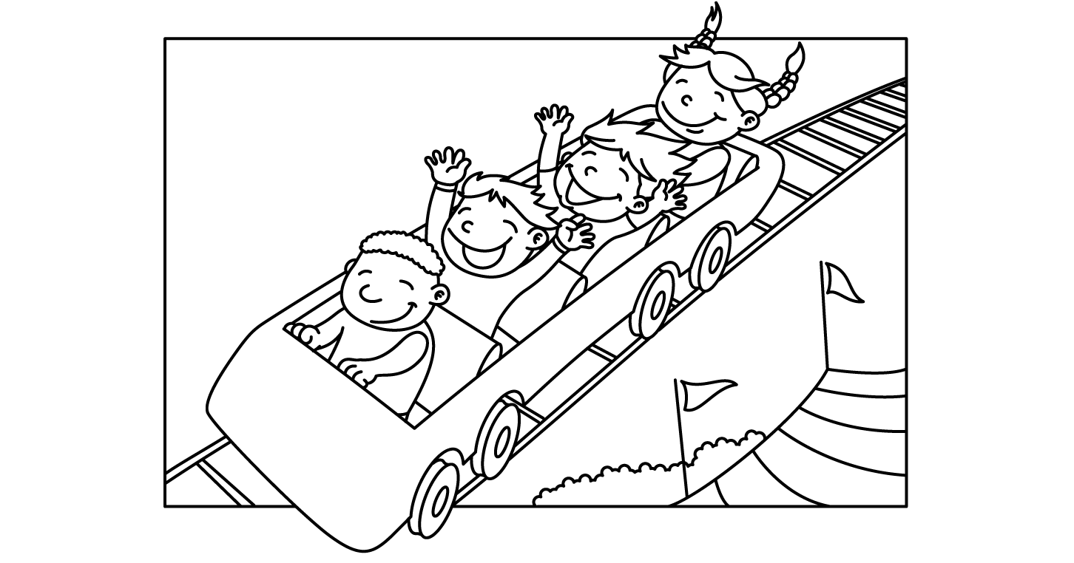

MONTH of JULY 2021
Sunday | Monday | Tuesday | Wednesday | Thursday | Friday | Saturday
 |  |  |  | 1  Lap Swim 12-1pm  Private: 10am  10:30, 11, 11:30, 12; 12:30  Closed at 5pm | 2  Lap Swim 12-1pm  Lap Swim 5-6pm  Private: 11, 11:30, 12; 12:30; 5, 5:30 | 3  Pool Party  10:30-12:30:  6:30-8:30:
4  Pool Party  10:30-12:30  Pool Closed @5pm!! | 5  Lap Swim 12-1pm  Lap Swim 5-6pm  Private: 11, 11:30, 12; 12:30; 5, 5:30 | 6  Lap Swim 12-1pm  Lap Swim 5-6pm  Private: 11, 11:30, 12; 12:30; 5, 5:30 | 7  Lap Swim 12-1pm  Lap Swim 5-6pm  Private: 11, 11:30, 12; 12:30; 5, 5:30 | 8  Lap Swim 12-1pm  Lap Swim 5-6pm  Private: 11, 11:30, 12; 12:30; 5, 5:30 | 9  Lap Swim 12-1pm  Lap Swim 5-6pm  Private: 11, 11:30, 12; 12:30; 5, 5:30 | 10  Pool Party  10:30-12:30:  6:30-8:30: 4-H Pool Party Jacki Stubbendick 525-4879
11  Pool Party  10:30-12:30 | 12  Lap Swim 12-1pm  Lap Swim 5-6pm  Private: 11, 11:30, 12; 12:30; 5, 5:30 | 13  Lap Swim 12-1pm  Lap Swim 5-6pm  Private: 11, 11:30, 12; 12:30; 5, 5:30 | 14  Lap Swim 12-1pm  Lap Swim 5-6pm  Private: 11, 11:30, 12; 12:30; 5, 5:30 | 15  Lap Swim 12-1pm  Lap Swim 5-6pm  Private: 11, 11:30, 12; 12:30; 5, 5:30 | 16  Lap Swim 12-1pm  Lap Swim 5-6pm  Private: 11, 11:30, 12; 12:30; 5, 5:30 | 17  Pool Party  10:30-12:30  6:30-8:30:
18  Pool Party  10:30-12:30 | 19  Lap Swim 12-1pm  Lap Swim 5-6pm  Private: 11, 11:30, 12; 12:30; 5, 5:30 | 20  Lap Swim 12-1pm  Lap Swim 5-6pm  Private: 11, 11:30, 12; 12:30; 5, 5:30 | 21  Lap Swim 12-1pm  Lap Swim 5-6pm  Private: 11, 11:30, 12; 12:30; 5, 5:30 | 22  Lap Swim 12-1pm  Lap Swim 5-6pm  Private: 11, 11:30, 12; 12:30; 5, 5:30 | 23  Lap Swim 12-1pm  Lap Swim 5-6pm  Private: 11, 11:30, 12; 12:30; 5, 5:30 | 24  Pool Party  10:30-12:30  6:30-8:30:
25  Pool Party  10:30-12:30 | 26  Lap Swim 12-1pm  Lap Swim 5-6pm  Private: 11, 11:30, 12; 12:30; 5, 5:30 | 27  Lap Swim 12-1pm  Lap Swim 5-6pm  Private: 11, 11:30, 12; 12:30; 5, 5:30 | 28  Lap Swim 12-1pm  Lap Swim 5-6pm  Private: 11, 11:30, 12; 12:30; 5, 5:30 | 29  Lap Swim 12-1pm  Lap Swim 5-6pm  Private: 11, 11:30, 12; 12:30; 5, 5:30 | 30  Lap Swim 12-1pm  Lap Swim 5-6pm  Private: 11, 11:30, 12; 12:30; 5, 5:30 | 31  Pool Party  10:30-12:30  6:30-8:30:

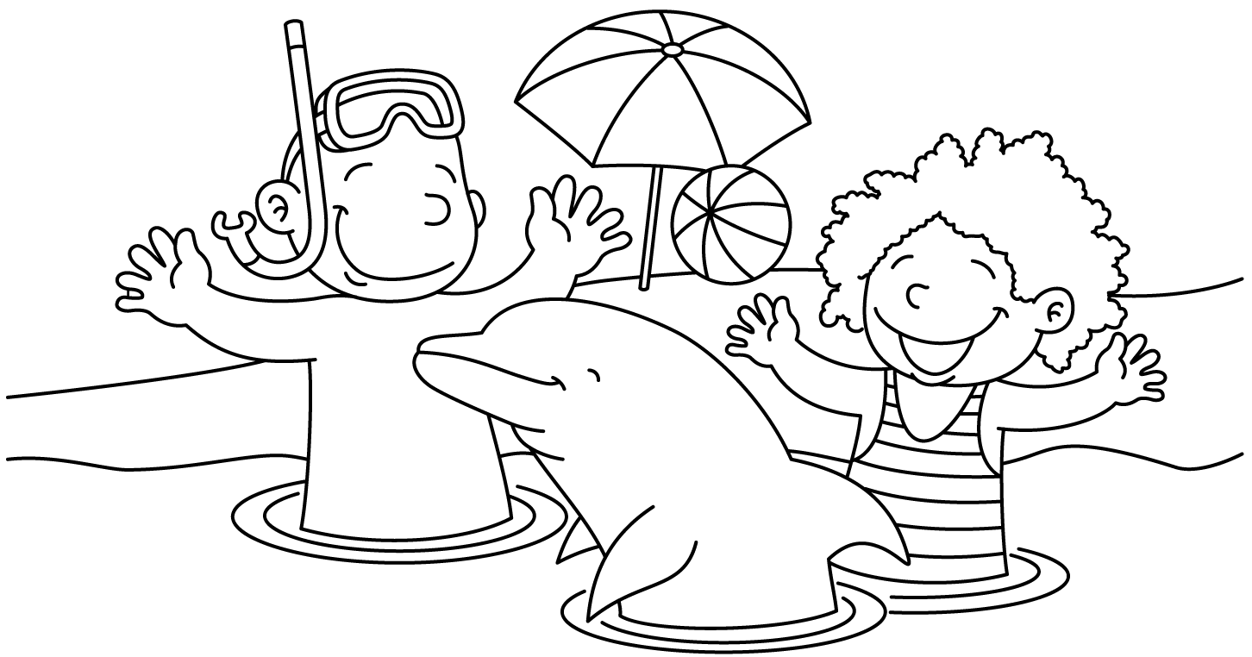

MONTH of AUGUST 2021
Sunday | Monday | Tuesday | Wednesday | Thursday | Friday | Saturday
1  Pool Party  10:30-12:30 | 2  Lap Swim 12-1pm  Lap Swim 5-6pm  Private: 11, 11:30, 12; 12:30; 5, 5:30 | 3  Lap Swim 12-1pm  Lap Swim 5-6pm  Private: 11, 11:30, 12; 12:30; 5, 5:30 | 4  Lap Swim 12-1pm  Lap Swim 5-6pm  Private: 11, 11:30, 12; 12:30; 5, 5:30 | 5  Lap Swim 12-1pm  Lap Swim 5-6pm  Private: 11, 11:30, 12; 12:30; 5, 5:30 | 6  Lap Swim 12-1pm  Lap Swim 5-6pm  Private: 11, 11:30, 12; 12:30; 5, 5:30 | 7  Pool Party  10:30-12:30  6:30-8:30:
8  NO pool Party | 9  Lap Swim 12-1pm  Lap Swim 5-6pm  Private: 11, 11:30, 12; 12:30; 5, 5:30: | 10  Lap Swim 12-1pm  Lap Swim 5-6pm  Private: 11, 11:30, 12; 12:30; 5, 5:30: | 11  Lap Swim 12-1pm  Lap Swim 5-6pm  Private: 11, 11:30, 12; 12:30; 5, 5:30: | 12  1st Day of School  Pool open 5-7pm ONLY  NO LAP SWIM | 13  Pool open 5-7pm ONLY  **SCHOOL SWIM**  NO LAP SWIM | 14  NO pool Party
15  NO pool Party | 16  Pool open 5-7pm ONLY  **SCHOOL SWIM**  NO LAP SWIM | 17  Pool open 5-7pm ONLY  **SCHOOL SWIM**  NO LAP SWIM | 18  Pool open 5-7pm ONLY  **SCHOOL SWIM**  NO LAP SWIM | 19  Pool open 5-7pm ONLY  **SCHOOL SWIM**  NO LAP SWIM | 20  POOL CLOSED

MONTH of June 2021
Sunday | Monday | Tuesday | Wednesday | Thursday | Friday | Saturday
 | 31  Lap Swim 12-1pm  Lap Swim 5-6pm  Public Lessons: 10:15-11am; 11:15-noon;  5-5:45pm | 1  Lap Swim 12-1pm  Lap Swim 5-6pm  Public Lessons: 10:15-11am; 11:15-noon;  5-5:45pm | 2  Lap Swim 12-1pm  Lap Swim 5-6pm  Public Lessons: 10:15-11am; 11:15-noon;  5-5:45pm | 3  Lap Swim 12-1pm  Lap Swim 5-6pm  Public Lessons: 10:15-11am; 11:15-noon;  5-5:45pm | 4  Lap Swim 12-1pm  Lap Swim 5-6pm | 5  Pool Party  10:30-12:30  6:30-8:30:
6  Pool Party  10:30-12:30 | 7  Lap Swim 12-1pm  Lap Swim 5-6pm  Public Lessons: 10:15-11am; 11:15-noon;  5-5:45pm | 8  Lap Swim 12-1pm  Lap Swim 5-6pm  Public Lessons: 10:15-11am; 11:15-noon;  5-5:45pm | 9  Lap Swim 12-1pm  Lap Swim 5-6pm  Public Lessons: 10:15-11am; 11:15-noon;  5-5:45pm | 10  Lap Swim 12-1pm  Lap Swim 5-6pm  Public Lessons: 10:15-11am; 11:15-noon;  5-5:45pm | 11  Lap Swim 12-1pm  Lap Swim 5-6pm | 12  Pool Party  10:30-12:30  6:30-8:30:
13  Pool Party  10:30-12:30 | 14  Lap Swim 12-1pm  Lap Swim 5-6pm  Public Lessons: 10:15-11am; 11:15-noon;  5-5:45pm | 15  Lap Swim 12-1pm  Lap Swim 5-6pm  Public Lessons: 10:15-11am; 11:15-noon;  5-5:45pm | 16  Lap Swim 12-1pm  Lap Swim 5-6pm  Public Lessons: 10:15-11am; 11:15-noon;  5-5:45pm | 17  Lap Swim 12-1pm  Lap Swim 5-6pm  Public Lessons: 10:15-11am; 11:15-noon;  5-5:45pm | 18  Lap Swim 12-1pm  Lap Swim 5-6pm | 19  Pool Party  10:30-12:30: CLOSED  6:30-8:30: CLOSED
20  Pool Party  10:30-12:30  CLOSED | 21  Lap Swim 12-1pm  Lap Swim 5-6pm  Public Lessons: 11:15-noon;  5-5:45pm | 22  Lap Swim 12-1pm  Lap Swim 5-6pm  Public Lessons: 11:15-noon;  5-5:45pm | 23  Lap Swim 12-1pm  Lap Swim 5-6pm  Public Lessons: 11:15-noon;  5-5:45pm | 24  Lap Swim 12-1pm  Lap Swim 5-6pm  Public Lessons: 11:15-noon;  5-5:45pm | 25  Lap Swim 12-1pm  Lap Swim 5-6pm | 26  Pool Party  10:30-12:30  CLOSED  6:30-8:30:  CLOSED
27  Pool Party  10:30-12:30:  CLOSED | 28 POOL OPENS  Lap Swim 12-1pm  Lap Swim 5-6pm  Private: 11, 11:30, 12; 12:30; 5, 5:30 | 29  Lap Swim 12-1pm  Lap Swim 5-6pm  Private: 11, 11:30, 12; 12:30; 5, 5:30 | 30  Lap Swim 12-1pm  Lap Swim 5-6pm  Private: 11, 11:30, 12; 12:30; 5, 5:30

