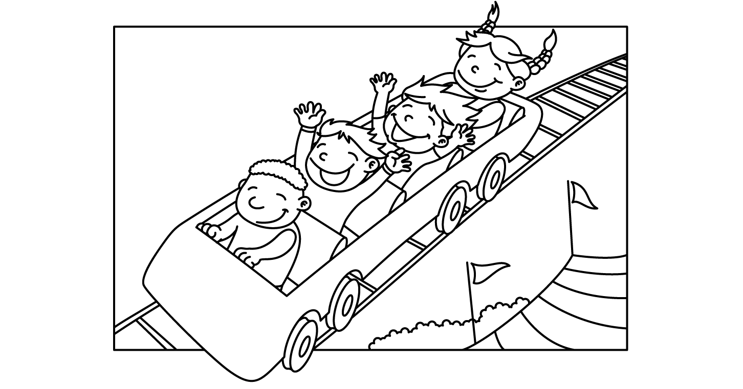REVISED 5/12/22

MONTH of May 2022
Sunday | Monday | Tuesday | Wednesday | Thursday | Friday | Saturday
1 | 2 | 3 | 4 | 5 | 6 | 7
8 | 9 | 10 | 11 | 12 | 13 | 14
15 | 16 | 17 | 18  Lap Swim 12-1pm  Lap Swim 5-6pm  Aerobics 12-1pm | 19  Lap Swim 12-1pm  Lap Swim 5-6pm | 20  Lap Swim 12-1pm  Lap Swim 5-6pm  Aerobics 12-1pm | 21  Pool Party  10:30-12:30  6:30-8:30:
22  Pool Party  10:30-12:30 | 23  Lap Swim 12-1pm  Lap Swim 5-6pm  Public Lessons: 10:15-11am; 11:15-noon;  5-5:45pm | 24  Lap Swim 12-1pm  Lap Swim 5-6pm  Public Lessons: 10:15-11am; 11:15-noon;  5-5:45pm | 25  Lap Swim 12-1pm  Lap Swim 5-6pm  Public Lessons: 10:15-11am; 11:15-noon;  5-5:45pm | 26  Lap Swim 12-1pm  Lap Swim 5-6pm  Public Lessons: 10:15-11am; 11:15-noon;  5-5:45pm | 27  Lap Swim 12-1pm  Lap Swim 5-6pm  Aerobics 12-1pm | 28  Pool Party  10:30-12:30  6:30-8:30:
29  Pool Party  10:30-12:30 | 30  Lap Swim 12-1pm  Lap Swim 5-6pm  Public Lessons: 10:15-11am; 11:15-noon;  5-5:45pm | 31  Lap Swim 12-1pm  Lap Swim 5-6pm  Public Lessons: 10:15-11am; 11:15-noon;  5-5:45pm

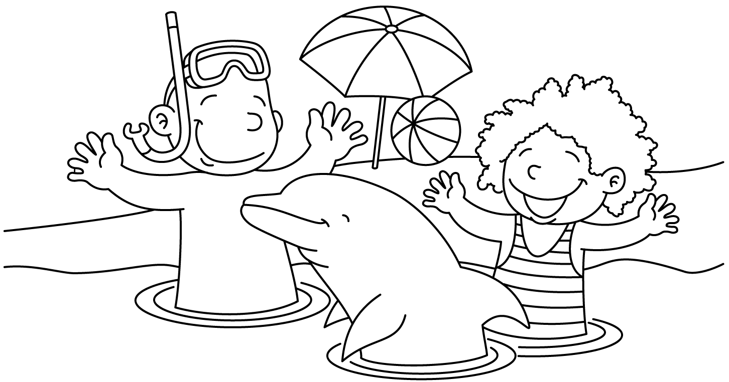 REVISED 5/12/22

MONTH of June 2022
Sunday | Monday | Tuesday | Wednesday | Thursday | Friday | Saturday
 |  |  | 1  Lap Swim 12-1pm  Lap Swim 5-6pm  Public Lessons: 10:15-11am; 11:15-noon;  5-5:45pm | 2  Lap Swim 12-1pm  Lap Swim 5-6pm  Public Lessons: 10:15-11am; 11:15-noon;  5-5:45pm | 3  Lap Swim 12-1pm  Lap Swim 5-6pm  Aerobics 12-1pm  Teten family will pay for party entries | 4  Pool Party  10:30-12:30  6:30-8:30:
5  Pool Party  10:30-12:30 | 6  Lap Swim 12-1pm  NO LAP SWIM – Swim Meet 5pm  Public Lessons: 10:15-11am; 11:15-noon; | 7  Lap Swim 12-1pm  Lap Swim 5-6pm  Public Lessons: 10:15-11am; 11:15-noon;  5-5:45pm | 8  Lap Swim 12-1pm  Lap Swim 5-6pm  Public Lessons: 10:15-11am; 11:15-noon;  5-5:45pm | 9  Lap Swim 12-1pm  Lap Swim 5-6pm  Public Lessons: 10:15-11am; 11:15-noon;  5-5:45pm | 10  Lap Swim 12-1pm  Lap Swim 5-6pm  Aerobics 12-1pm  Public Lessons 5-5:45pm | 11  Pool Party  10:30-12:30  6:30-8:30: Erin Singh 560-7845
12  Pool Party  10:30-12:30 | 13  Lap Swim 12-1pm  Lap Swim 5-6pm  Public Lessons: 11:15-noon;  5-5:45pm | 14  Lap Swim 12-1pm  Lap Swim 5-6pm  Public Lessons: 11:15-noon;  5-5:45pm | 15  Lap Swim 12-1pm  NO LAP SWIM – Swim Meet 5pm  Public Lessons: 11:15-noon;  5-5:45pm | 16  Lap Swim 12-1pm  Lap Swim 5-6pm  Public Lessons: 11:15-noon;  5-5:45pm | 17  Lap Swim 12-1pm  Lap Swim 5-6pm  Public Lessons  5-5:45pm  Aerobics 12-1pm | 18  Pool Party  10:30-12:30: Angela Bickford 269-8110  6:30-8:30:  Cathy Stewart cstewart@lps.org
19  Pool Party  10:30-12:30: | 20  Lap Swim 12-1pm  Lap Swim 5-6pm  Private: 10am  10:30, 11, 11:30, 12; 12:30; 5, 5:30  Aerobics 12-1pm | 21  Lap Swim 12-1pm  Lap Swim 5-6pm  Private: 10am  10:30, 11, 11:30, 12; 12:30; 5, 5:30 | 22  Lap Swim 12-1pm  Lap Swim 5-6pm  Private: 10am  10:30, 11, 11:30, 12; 12:30; 5, 5:30  Aerobics 12-1pm | 23  Lap Swim 12-1pm  Lap Swim 5-6pm  Private: 10am  10:30, 11, 11:30, 12; 12:30; 5, 5:30 | 24  Lap Swim 12-1pm  Lap Swim 5-6pm  Private: 10am  10:30, 11, 11:30, 12; 12:30; 5, 5:30  Aerobics 12-1pm | 25  Pool Party  10:30-12:30:  6:30-8:30: Cathy Stewart – Swim Team Party
26  Pool Party  10:30-12:30:  6:30-8:30: Tracy Ensor 432-8637 | 27  Lap Swim 12-1pm  Lap Swim 5-6pm  Private: 10am  10:30, 11, 11:30, 12; 12:30; 5, 5:30  Aerobics 12-1pm | 28  Lap Swim 12-1pm  Lap Swim 5-6pm  Private: 10am  10:30, 11, 11:30, 12; 12:30; 5, 5:30 | 29  Lap Swim 12-1pm  Lap Swim 5-6pm  Private: 10am  10:30, 11, 11:30, 12; 12:30; 5, 5:30  Aerobics 12-1pm | 30  Lap Swim 12-1pm  Lap Swim 5-6pm  Private: 10am  10:30, 11, 11:30, 12; 12:30; 5, 5:30

MONTH of July 2022
Sunday | Monday | Tuesday | Wednesday | Thursday | Friday | Saturday
 |  |  |  |  | 1  Lap Swim 12-1pm  Lap Swim 5-6pm  Private: 10am  10:30, 11, 11:30, 12; 12:30; 5, 5:30  Aerobics 12-1pm | 2  Pool Party  10:30-12:30  6:30-8:30: Taylor Dennis 402-269-8160
3  Pool Party  10:30-12:30 | 4  No Lap Swim  No Private Lessons  No aerobics | 5  Lap Swim 12-1pm  Lap Swim 5-6pm  Private: 11, 11:30, 12; 12:30; 5, 5:30 | 6  Lap Swim 12-1pm  Lap Swim 5-6pm  Private: 11, 11:30, 12; 12:30; 5, 5:30  Aerobics 12-1pm | 7  Lap Swim 12-1pm  Lap Swim 5-6pm  Private: 11, 11:30, 12; 12:30; 5, 5:30 | 8  Lap Swim 12-1pm  Lap Swim 5-6pm  Private: 11, 11:30, 12; 12:30; 5, 5:30  Aerobics 12-1pm | 9  Pool Party  10:30-12:30  6:30-8:30: Amanda Potts 875-3528
10  Pool Party  10:30-12:30 | 11  Lap Swim 12-1pm  Lap Swim 5-6pm  Private: 11, 11:30, 12; 12:30; 5, 5:30  Aerobics 12-1pm | 12  Lap Swim 12-1pm  Lap Swim 5-6pm  Private: 11, 11:30, 12; 12:30; 5, 5:30 | 13  Lap Swim 12-1pm  Lap Swim 5-6pm  Private: 11, 11:30, 12; 12:30; 5, 5:30  Aerobics 12-1pm | 14  Lap Swim 12-1pm  Lap Swim 5-6pm  Private: 11, 11:30, 12; 12:30; 5, 5:30 | 15  Lap Swim 12-1pm  Lap Swim 5-6pm  Private: 11, 11:30, 12; 12:30; 5, 5:30  Aerobics 12-1pm | 16  Pool Party  10:30-12:30  6:30-8:30:
17  Pool Party  10:30-12:30 | 18  Lap Swim 12-1pm  Lap Swim 5-6pm  Private: 11, 11:30, 12; 12:30; 5, 5:30  Aerobics 12-1pm | 19  Lap Swim 12-1pm  Lap Swim 5-6pm  Private: 11, 11:30, 12; 12:30; 5, 5:30 | 20  Lap Swim 12-1pm  Lap Swim 5-6pm  Private: 11, 11:30, 12; 12:30; 5, 5:30  Aerobics 12-1pm | 21  Lap Swim 12-1pm  Lap Swim 5-6pm  Private: 11, 11:30, 12; 12:30; 5, 5:30 | 22  Lap Swim 12-1pm  Lap Swim 5-6pm  Private: 11, 11:30, 12; 12:30; 5, 5:30  Aerobics 12-1pm | 23  Pool Party  10:30-12:30  6:30-8:30:
24  Pool Party  10:30-12:30 | 25  Lap Swim 12-1pm  Lap Swim 5-6pm  Private: 11, 11:30, 12; 12:30; 5, 5:30  Aerobics 12-1pm | 26  Lap Swim 12-1pm  Lap Swim 5-6pm  Private: 11, 11:30, 12; 12:30; 5, 5:30 | 27  Lap Swim 12-1pm  Lap Swim 5-6pm  Private: 11, 11:30, 12; 12:30; 5, 5:30  Aerobics 12-1pm | 28  Lap Swim 12-1pm  Lap Swim 5-6pm  Private: 11, 11:30, 12; 12:30; 5, 5:30 | 29  Lap Swim 12-1pm  Lap Swim 5-6pm  Private: 11, 11:30, 12; 12:30; 5, 5:30  Aerobics 12-1pm | 30  Pool Party  10:30-12:30  6:30-8:30: Leslie McIntosh

MONTH of August 2022
Sunday | Monday | Tuesday | Wednesday | Thursday | Friday | Saturday
31 | 1  Lap Swim 12-1pm  Lap Swim 5-6pm  Private: 11, 11:30, 12; 12:30; 5, 5:30  Aerobics 12-1pm | 2  Lap Swim 12-1pm  Lap Swim 5-6pm  Private: 11, 11:30, 12; 12:30; 5, 5:30 | 3  Lap Swim 12-1pm  Lap Swim 5-6pm  Private: 11, 11:30, 12; 12:30; 5, 5:30  Aerobics 12-1pm | 4  Lap Swim 12-1pm  Lap Swim 5-6pm  Private: 11, 11:30, 12; 12:30; 5, 5:30 | 5  Lap Swim 12-1pm  Lap Swim 5-6pm  Private: 11, 11:30, 12; 12:30; 5, 5:30  Aerobics 12-1pm | 6  Pool Party  10:30-12:30 Jamie Woods 525-4667  6:30-8:30: ALL STAFF POOL PARTY
7  NO POOL PARTIES  Clean-up Day | 8  Lap Swim 12-1pm  Lap Swim 5-6pm  Private: 11, 11:30, 12; 12:30; 5, 5:30  Aerobics 12-1pm | 9  Lap Swim 12-1pm  Lap Swim 5-6pm  Private: 11, 11:30, 12; 12:30; 5, 5:30 | 10  Lap Swim 12-1pm  Lap Swim 5-6pm  Private: 11, 11:30, 12; 12:30; 5, 5:30  Aerobics 12-1pm | 11  Lap Swim 12-1pm  Lap Swim 5-6pm  Private: 11, 11:30, 12; 12:30; 5, 5:30 | 12  Lap Swim 12-1pm  Lap Swim 5-6pm  Private: 11, 11:30, 12; 12:30; 5, 5:30  Aerobics 12-1pm | 13
14 | 16 | 17 | 18 | 19 | 20 | 21
22 | 23 | 24 | 25 | 26 | 27 | 28
29 | 30 | 31

