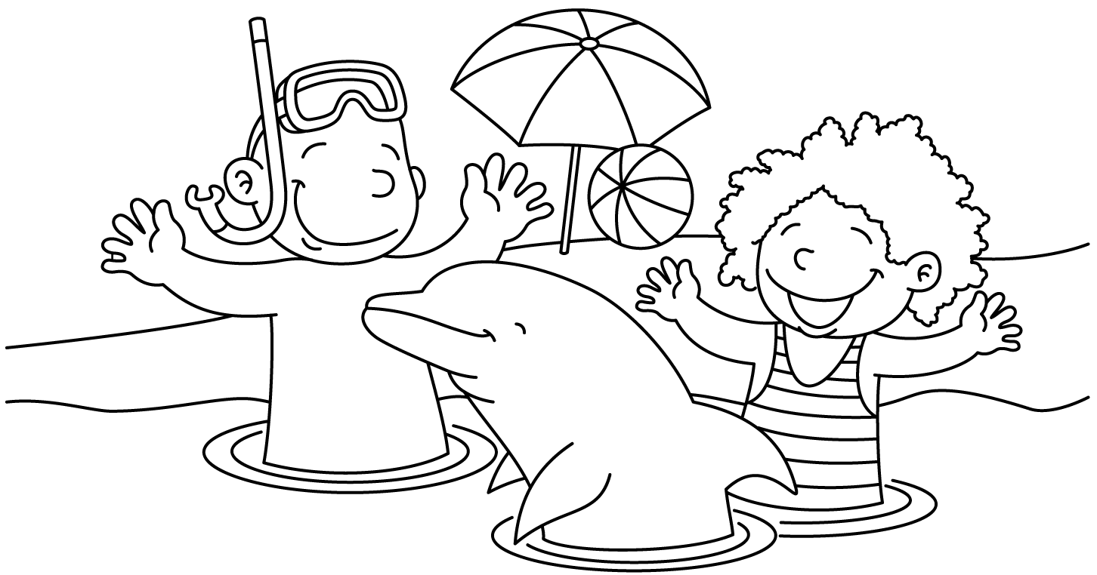

MONTH of July 2022
Sunday | Monday | Tuesday | Wednesday | Thursday | Friday | Saturday
 |  |  |  |  | 1  Lap Swim 12-1pm  Lap Swim 5-6pm  Private: 10am  10:30, 11, 11:30, 12; 12:30; 5, 5:30  Aerobics 12-1pm | 2  Pool Party  10:30-12:30  6:30-8:30: Taylor Dennis 402-269-8160
3  Pool Party  10:30-12:30 | 4  No Lap Swim  No Private Lessons  No aerobics | 5  Lap Swim 12-1pm  Lap Swim 5-6pm  Private: 11, 11:30, 12; 12:30; 5, 5:30 | 6  Lap Swim 12-1pm  Lap Swim 5-6pm  Private: 11, 11:30, 12; 12:30; 5, 5:30  Aerobics 12-1pm | 7  Lap Swim 12-1pm  Lap Swim 5-6pm  Private: 11, 11:30, 12; 12:30; 5, 5:30 | 8  Lap Swim 12-1pm  Lap Swim 5-6pm  Private: 11, 11:30, 12; 12:30; 5, 5:30  Aerobics 12-1pm | 9  Pool Party  10:30-12:30  Mason Sieber  402-862-7099  6:30-8:30: Amanda Potts 875-3528
10  Pool Party  10:30-12:30 | 11  Lap Swim 12-1pm  Lap Swim 5-6pm  Private: 11, 11:30, 12; 12:30; 5, 5:30  Aerobics 12-1pm | 12  Lap Swim 12-1pm  Lap Swim 5-6pm  Private: 11, 11:30, 12; 12:30; 5, 5:30 | 13  Lap Swim 12-1pm  Lap Swim 5-6pm  Private: 11, 11:30, 12; 12:30; 5, 5:30  Aerobics 12-1pm | 14  Lap Swim 12-1pm  Lap Swim 5-6pm  Private: 11, 11:30, 12; 12:30; 5, 5:30 | 15  Lap Swim 12-1pm  Lap Swim 5-6pm  Private: 11, 11:30, 12; 12:30; 5, 5:30  Aerobics 12-1pm | 16  Pool Party  10:30-12:30  6:30-8:30:
17  Pool Party  10:30-12:30 | 18  Lap Swim 12-1pm  Lap Swim 5-6pm  Private: 11, 11:30, 12; 12:30; 5, 5:30  Aerobics 12-1pm | 19  Lap Swim 12-1pm  Lap Swim 5-6pm  Private: 11, 11:30, 12; 12:30; 5, 5:30 | 20  Lap Swim 12-1pm  Lap Swim 5-6pm  Private: 11, 11:30, 12; 12:30; 5, 5:30  Aerobics 12-1pm | 21  Lap Swim 12-1pm  Lap Swim 5-6pm  Private: 11, 11:30, 12; 12:30; 5, 5:30 | 22  Lap Swim 12-1pm  Lap Swim 5-6pm  Private: 11, 11:30, 12; 12:30; 5, 5:30  Aerobics 12-1pm | 23  Pool Party  10:30-12:30  6:30-8:30: Jen Hansen 402-215-4030
24  Pool Party  10:30-12:30 | 25  Lap Swim 12-1pm  Lap Swim 5-6pm  Private: 11, 11:30, 12; 12:30; 5, 5:30  Aerobics 12-1pm | 26  Lap Swim 12-1pm  Lap Swim 5-6pm  Private: 11, 11:30, 12; 12:30; 5, 5:30 | 27  Lap Swim 12-1pm  Lap Swim 5-6pm  Private: 11, 11:30, 12; 12:30; 5, 5:30  Aerobics 12-1pm | 28  Lap Swim 12-1pm  Lap Swim 5-6pm  Private: 11, 11:30, 12; 12:30; 5, 5:30 | 29  Lap Swim 12-1pm  Lap Swim 5-6pm  Private: 11, 11:30, 12; 12:30; 5, 5:30  Aerobics 12-1pm | 30  Pool Party  10:30-12:30  6:30-8:30: Leslie McIntosh
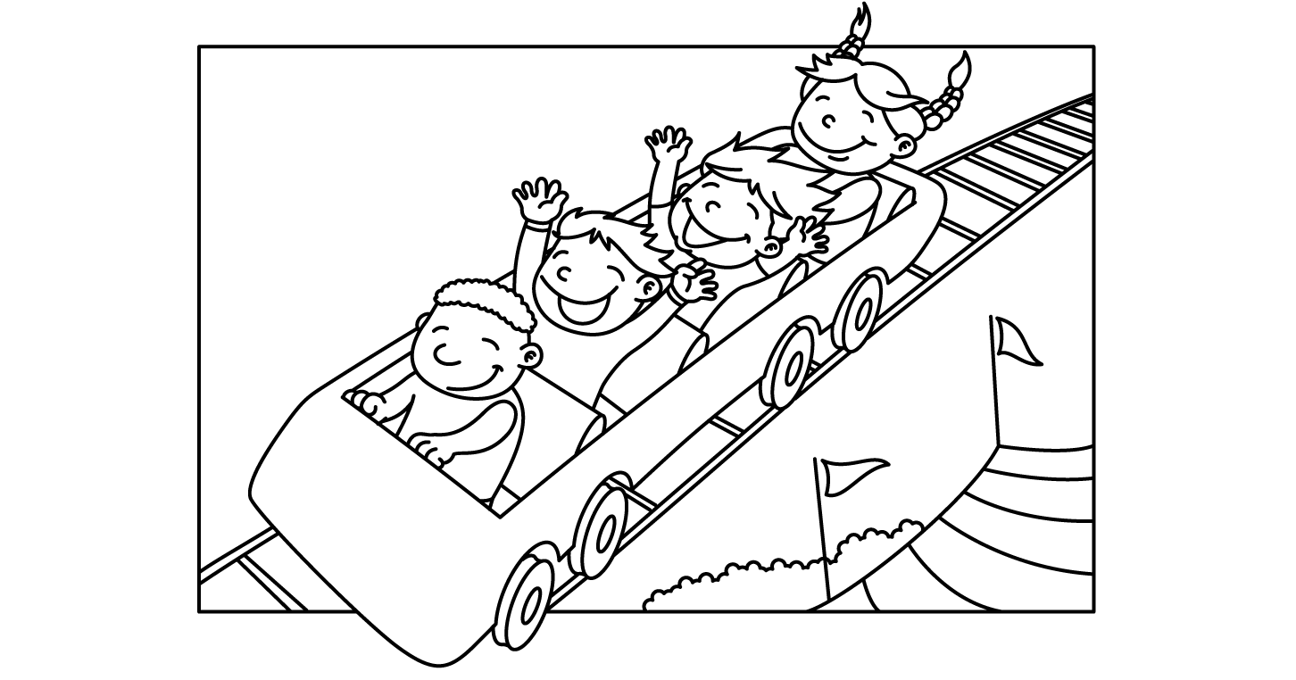

MONTH of August 2022
Sunday | Monday | Tuesday | Wednesday | Thursday | Friday | Saturday
31 | 1  Lap Swim 12-1pm  Lap Swim 5-6pm  Private: 11, 11:30, 12; 12:30; 5, 5:30  Aerobics 12-1pm | 2  Lap Swim 12-1pm  Lap Swim 5-6pm  Private: 11, 11:30, 12; 12:30; 5, 5:30 | 3  Lap Swim 12-1pm  Lap Swim 5-6pm  Private: 11, 11:30, 12; 12:30; 5, 5:30  Aerobics 12-1pm | 4  Lap Swim 12-1pm  Lap Swim 5-6pm  Private: 11, 11:30, 12; 12:30; 5, 5:30 | 5  Lap Swim 12-1pm  Lap Swim 5-6pm  Private: 11, 11:30, 12; 12:30; 5, 5:30  Aerobics 12-1pm | 6  Pool Party  10:30-12:30 Jamie Woods 525-4667  6:30-8:30: ALL STAFF POOL PARTY
7  NO POOL PARTIES  Clean-up Day | 8  Lap Swim 12-1pm  Lap Swim 5-6pm  Private: 11, 11:30, 12; 12:30; 5, 5:30  Aerobics 12-1pm | 9  Lap Swim 12-1pm  Lap Swim 5-6pm  Private: 11, 11:30, 12; 12:30; 5, 5:30 | 10  Lap Swim 12-1pm  Lap Swim 5-6pm  Private: 11, 11:30, 12; 12:30; 5, 5:30  Aerobics 12-1pm | 11  Lap Swim 12-1pm  Lap Swim 5-6pm  Private: 11, 11:30, 12; 12:30; 5, 5:30 | 12  Lap Swim 12-1pm  Lap Swim 5-6pm  Private: 11, 11:30, 12; 12:30; 5, 5:30  Aerobics 12-1pm | 13
14 | 16 | 17 | 18 | 19 | 20 | 21
22 | 23 | 24 | 25 | 26 | 27 | 28
29 | 30 | 31

