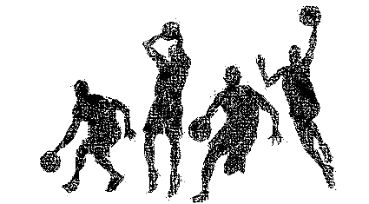
Adult 3 on 3 Basketball League
Syracuse Parks and Recreation
PO Box F
Syracuse, NE 68446
402.269.2173
402.269.0742
syracuseparksandrec@syracusene.com

Team Name: ____________________________ Captain: __________________________
Contact Phone #: ________________________ Email: ____________________________
(Circle one)
Circle one: Men OR Women
$80 registration fee per team – Due February 13, 2023 *Tournament prize will depend on interest.
I agree to abide by the rules and regulations as set forth by the Syracuse Parks and Recreation. I understand that the Parks and Rec does not provide insurance coverage for the above listed facility members or program participants and that I am responsible for my own personal coverage. I understand that the fee must accompany the registration form. I understand that there is no cash refund unless the program is canceled. I will also conduct myself with a positive attitude toward coaches, opposing team players, and Parks and Rec staff members during the course of the season. I hereby give permission for the Syracuse Parks and Recreation to use for promotional purposes any photos or videos taken during my involvement in this program. I agree that the Parks and Rec shall not be responsible for any personal injuries or losses sustained by me or my dependents while on any premises or as a result of any Parks and Rec sponsored activities. I further agree to indemnify and hold harmless the Parks and Rec from any claims or demands arising out of any such injuries or losses. By signing below I also acknowledge that my physical condition is such that my participation in this program will not put me at an increased health risk.
ROSTER
Player Name Signature E-mail
No more than 6 players on a roster-these will be the players you use all year.
*Checks must be payable to the Syracuse Parks and Recreation and submitted with the registration form.

