CITY OF SYRACUSE, NEBRASKA

WATER RATES

MONTHLY RATE

Service Charge $34.60 Minimum (3/4” & 1” Meter)
$123.50 Minimum ($1.5” Meter)
$216.50 Minimum (2” Meter)
$463.50 Minimum (3” Meter)
$864.50 Minimum (4” Meter)
0 - 10,000 gallons $ 2.25 per M Gal. UTILITIES RATES
10,001 - 20,000 gallons $ 2.70 per M Gal.
20,001 - Excess gallons $ 3.25 per M Gal. CITY OF
SYRACUSE, NEBRASKA
NON-RESIDENTIAL BILLING
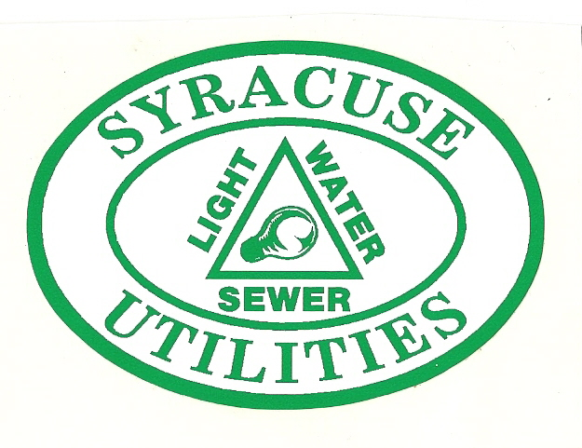
Service Charge $69.20 Minimum
0 - 10,000 gallons $ 3.75 per M Gal.
10,001 – 20,000 gallons $ 4.25 per M Gal.
20,001 – Excess gallons $ 4.50 per M Gal.

BULK RATE
0 – 1000 gallons $10.00 Minimum
Excess gallons $ 5.00 per M Gal.

Non-Residential billing is for customers
outside City limits.
Meters are read monthly and all rates
including service charge are based on
The Syracuse Utilities is owned and operated by the City. The complete distribution systems of lights, water and sewer are owned by the City and rates are set to insure covering of operation and expansion and still offer to the consumer a rate as low as possible.
such amount of time. Prices above are
per 1,000 gallons.
Multiple Dwelling and Trailer Courts
install one large water meter. The
large water meter has one minimum
charge. The water rates do not have
a minimum charge per dwelling or lot.

SEWER RATE
Service Charge $23.75 Minimum
plus $2.65 per M gallons of water used during
the months of December, January, and February. Multiple Dwellings and Trailer Courts
are the minimum sewer rate of $15.00
per dwelling or lot.

Effective November 15, 2024

